* **تست ثبت داده کلاستر 100تایی low level در SQL**

Table 1. 1 Table (100 Columns) - 1 KHz – Counter=1000

|  |  |  |  |  |
| --- | --- | --- | --- | --- |
| Period: 1 ms | Time Delay (ms) | Time (ms) per one | Data lost | CPU Usage |
| 1 Table | 6213 | 6.213 | no | 10-13% |
| 1 Table | 6281 | 6.281 | no |  |
| 1 Table | 7931 | 7.931 | no |  |
| 1 Table | 7961 | 7.961 | no |  |
| 1 Table | 6572 | 6.572 | no |  |

Table 2. 1 Table (100 Columns) - Normal While loop – Counter=1000

|  |  |  |  |  |
| --- | --- | --- | --- | --- |
| While loop | Time Delay (ms) | Time (ms) per one | Data lost | CPU Usage |
| 1 Table | 3797 | 3.797 | no | 17-18% |
| 1 Table | 5784 | 5.784 | no |  |
| 1 Table | 3678 | 3.678 | no |  |
| 1 Table | 3665 | 3.665 | no |  |
| 1 Table | 3867 | 3.867 | no |  |

Table 3. 10 Tables (100 Columns) - 1 KHz – Counter=1000

|  |  |  |  |  |
| --- | --- | --- | --- | --- |
| Period: 1 ms | Time Delay (ms) | Time (ms) per one | Data lost | CPU Usage |
| 10 Table | 48866 | 48.866 | no | 19-20% |
| 10 Table | 39784 | 39.784 | no |  |
| 10 Table | 39359 | 39.359 | no |  |
| 10 Table | 43072 | 43.072 | no |  |

Table 4. 10 Tables (100 Columns) - Normal While loop – Counter=1000

|  |  |  |  |  |
| --- | --- | --- | --- | --- |
| While loop | Time Delay (ms) | Time (ms) per one | Data lost | CPU Usage |
| 10 Table | 34968 | 34.968 | no | 20% |
| 10 Table | 38327 | 38.327 | no |  |
| 10 Table | 37846 | 37.846 | no |  |
| 10 Table | 34492 | 34.492 | no |  |

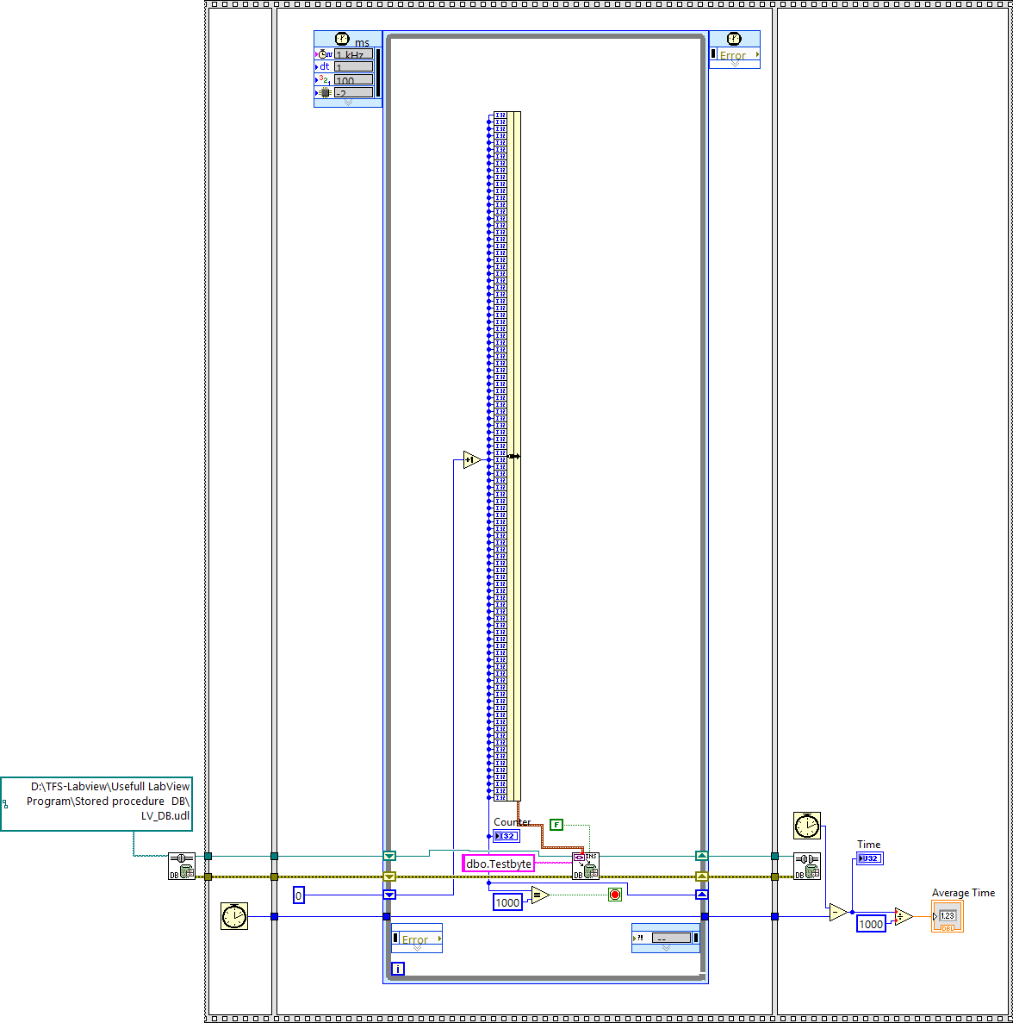

Figure 1. Write on SQL 1 Table (100 Columns) - 1 KHz

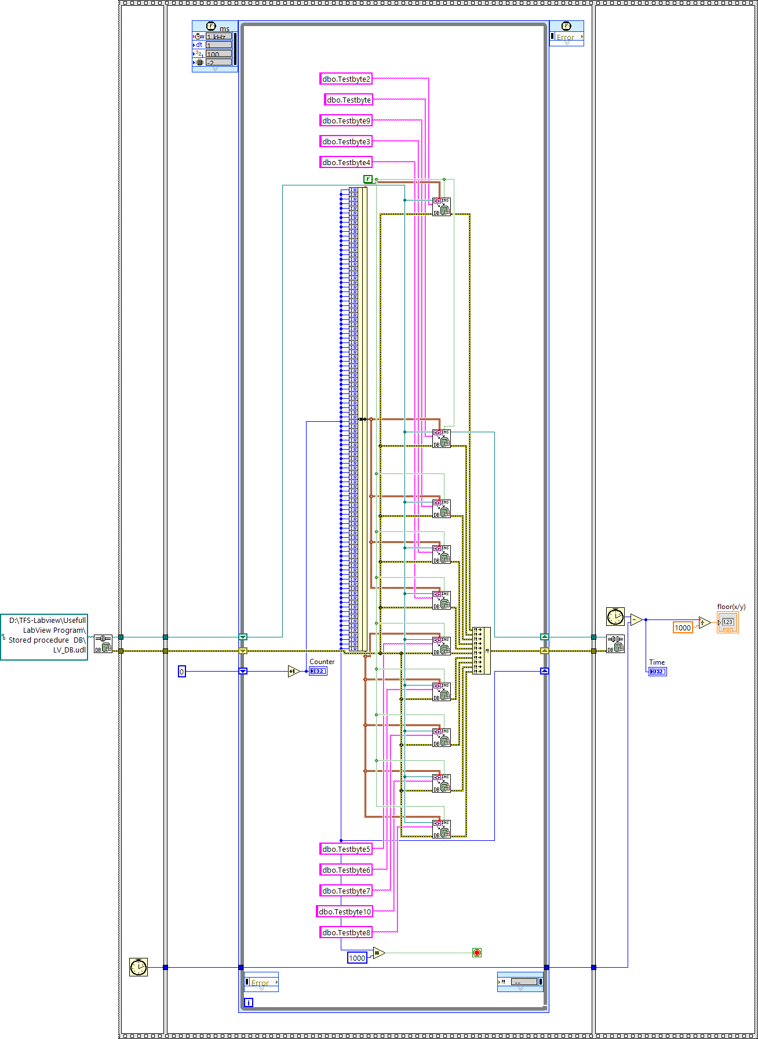

Figure 2. Write on SQL 10 Tables (100 Columns) - 1 KHz

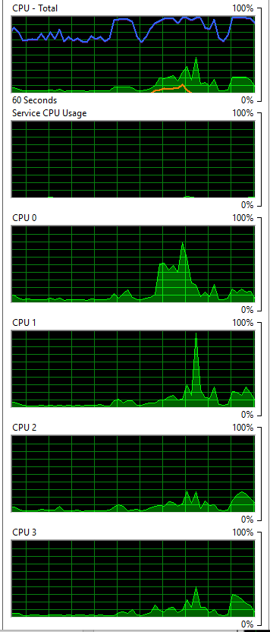

Figure 3. CPU Usage 1 Tables (100 Columns) - 1 KHz

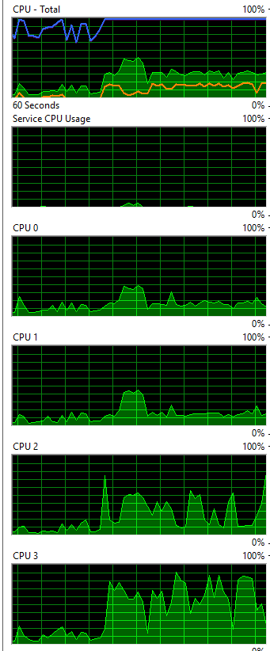

Figure 4. CPU Usage 1 Tables (100 Columns) - Normal While loop

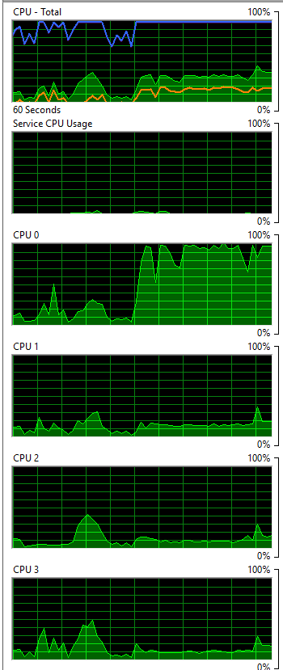

Figure 5. CPU Usage 10 Tables (100 Columns) - 1 KHz

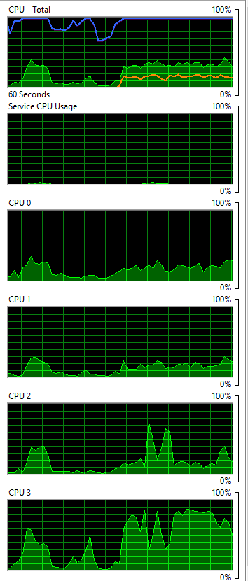

Figure 6. CPU Usage 10 Tables (100 Columns) - Normal While loop